|  |
| --- |
| **Plant Growth Android App – image-based monitoring and measurement of plant growth**  Zhu Pengming 1, *, Li Qingchen1, Shen Yiyang1, Li Zherui1, Samuel Ken-En Gan1,2, # ­­­­­­­  1App and Product Development Lab, Wenzhou-Kean University, Wenzhou, Zhejiang, China  2Zhejiang Chinese Medical University, Hangzhou 330111, Zhejiang, China  **3**Wenzhou Municipal Key Lab of Applied Biomedical and Biopharmaceutical Informatics,  Wenzhou-Kean University, Wenzhou 325060, Zhejiang China  **4**Zhejiang Bioinformatics International Science and Technology Cooperation Center, Wenzhou-  Kean University, Wenzhou 325060, Zhejiang China  **5**Department of Psychology, James Cook University, Singapore 387380, Singapore  #To whom correspondence should be addressed: [samgan@apdskeg.com](mailto:samgan@apdskeg.com); DOI: 10.30943/X  Handling Editor: XXXXX . |

# ABSTRACT

Accurate measurement of plant growth is important to botanical research and various fields. However, traditional measurement tools are laborious and may not be always accessible. To address this issue, the Plant Growth Android App utilizes image processing techniques to automatically monitor plant height from photos, leveraging the smartphone camera and the OpenCV library. By referencing target object heights, scaling conversions enable a more rapid and accurate estimation. The application, available in the Google Play Store, can thus be used to rapidly evaluate plant growth in height with applications in botanical studies and practical applications in a user-friendly and convenient manner.

# INTRODUCTION

The popularity of smartphones has fueled and been fueled by the many app developments. In the recent COVID-19 pandemic, innovations in the form of smartphone apps [1] [2] [3] and associated devices grew in number [4] [5]

While the lockdown measures increased the use of apps and associated devices, the apps developed for the pandemic use were built on the back of tool apps to measure or detect. Apps that calculated distance (e.g., GelApp [12], and are [6] or volume [7] laid the fundamentals of the image analysis that coupled with more advanced image analysis allowed novel applications like skin monitoring [8].

The importance of food security and productivity as demonstrated during the recent pandemic catalyzed high technology-based farming. The evaluation of the effectiveness of these novel farming methods requires measurement methods that are fast and accurate. In agriculture and botanical research, the growth of plant height is often an indicator of water balance, carbohydrate transport, and light inception [9]. Given its easy visual detection, it can easily benefit from the use of image processing. Traditional measurement tools may not be readily available or convenient to use. Therefore, the development of a convenient and accurate measurement tool is essential. With the widespread use of smartphones, designing mobile applications with image processing techniques has become a convenient and effective way to monitor the growth of plants.

Image processing has been used to measure plant health parameters such as leaf area [10]. These capture methods generally utilize a smartphone with further analysis using the more power processing power of larger devices e.g., desktops/laptops.

Here we created the Plant Growth app to rapidly measure and monitor plant height leveraging on the smartphone camera and OpenCV image processing libraries. The height of the targeted plant object could be easily calculated by a scaling conversion with the known pot height (actual height of the flowerpot/pixel height of the flowerpot in the image = actual height of the flower/pixel height of the flower). In cases were

pots were not used, a reference object near the plant of known height could be used。

# MATERIALS AND METHODS

The plant growth app was developed using Android Studio 2022.2.1 incorporating SQLiteOpenHelper and OpenCV libraries. SQLite was used as the database for fields such as the plant name, species, pot height, and measurement value to facilitate data management and query.

Through smartphone camera image capture, plant images can be uploaded and associated with the corresponding plant entry.

**Plant Segmentation**

For the method this application used to measure the height of the plant, there are two ways. First, we proposed a method for detecting flowerpots and plants using the Haar feature-based cascade classifier implemented in OpenCV. The Haar feature-based cascade classifier, introduced by Lienhart and Maydt [11], is a widely used approach for rapid object detection. It extends the set of Haar-like features and provides an effective solution for detecting objects in images. By leveraging this approach, we achieved XXX% accurate detection of flowerpots and plants in our system. We used 500 related pictures (from where?) to train the model of flowerpots and plants.

**Approach2: Manual Edit**

**Height Prediction**

**Pixel ratio**

By leveraging and inputting the known dimensions of the flowerpots or even nearby markers such as poles or buildings, a reference scale could be established for the unknown plant height quickly. This is done by comparing the pixels in the height of the target object and the unknown plant.

**Application on Android**

**Height calculation**

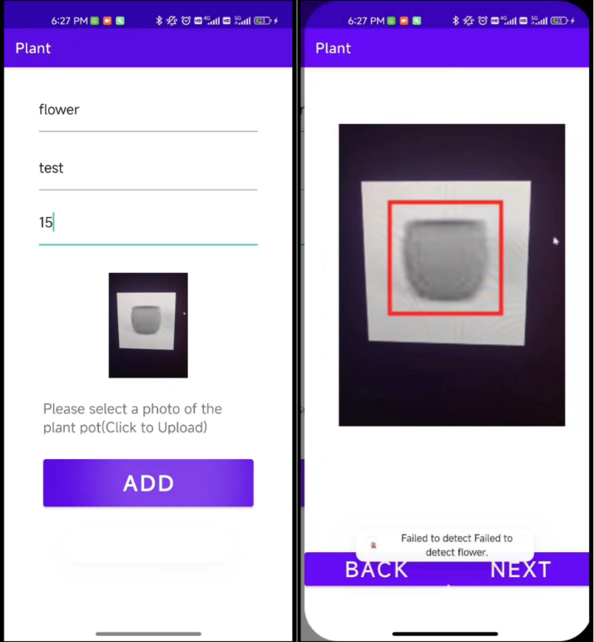

1. (b)

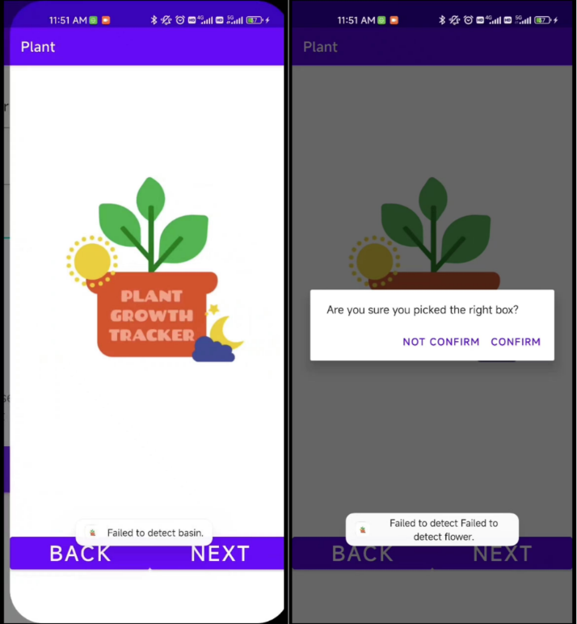

(c) (d)

Figure 1: a) Typing the plant information. b) Display test results. c) Undetected results d) The question of whether it is detected

First, users upload a picture of the plant by entering key information such as the name of the plant, the species, and the height of the pot. Next, the system will display the results generated by the model, and the user will confirm two key elements: first, to confirm that the pot is correctly matched; Second, verify that the plant is correctly identified. Users can confirm both at once in a dialog box. If the results are consistent, the system saves the data to the database. If the results are inconsistent, the user can choose to manually correct the data. This process is designed to ensure an accurate match between the plant and the pot, and to improve the reliability and accuracy of the application through user confirmation and correction.

**Height recalculation by manual editing**

Figure 2: a) Drawing frame for the flowerpot. b) Entering pot height. c) Drawing frame for only the flower. d) Calculated plant height.

# RESULTS or Results/DISCUSSION

# CONCLUSION

The APD Plant Growth App is a convenient mobile tool that utilizes machine learning algorithms and image processing methods to measure plant height and record growth status. While the application shows promise in measuring the heights of plants, further improvements can be made, including refining the performance of object detection algorithms and incorporating advanced techniques such as machine learning to enhance accuracy. This application provides a valuable tool for monitoring and measuring plant growth, which contributes to botanical research and practical applications.

# FUNDING

<Copy and paste in here. Keep font type and size as is>

# COMPLIANCE WITH ETHICAL STANDARDS

The research activities described in this document were conducted by established ethical standards and guidelines. All necessary ethical approvals, where required, were obtained before the commencement of the studies. The researchers

adhered to relevant ethical principles, ensuring the protection of participants' rights, privacy, and confidentiality throughout the research process.

# CONFLICTING INTERESTS

<Copy and paste in here. Keep font type and size as is>

# INFORMED CONSENT

Informed consent was obtained from all participants involved in the studies described in this document. Participants were provided with clear and comprehensive information regarding the nature of the research, its objectives, potential risks, benefits, and their rights as participants. They were allowed to ask questions and were assured that their participation was voluntary. Written consent was obtained from all participants before their involvement in the studies.

# AVAILABILITY

A video on the usage of the app can be found at <https://www.youtube.com/shorts/FQgtdXqstQA> and the app is available in the Google Play Store at https://play.google.com/store/apps/details?id=apd.bii.plantgrowthtracker&pli=1.

# AUTHOR CONTRIBUTIONS

Zhu Pengming played a key role in Android development, including manual editing, testing, and writing part of this paper.

Li Qingchen spearheaded image processing covering OpenCV's image segmentation and the creation of the plant height algorithm. He also participated in app testing and the writing of this paper.

Shen Yiyang actively participated in app development, testing, and paper drafting.

Li Zherui1 supported Li in OpenCV development and contributed to app development.

SKEG conceived the  
idea and supervised all aspects of the manuscript.

**REFERENCES**

[1] Zhen-Yi Chew, Wei-Ling Wu and Samuel Ken-En Gan. Application Notes - APD LAMP Diagnostic App: Automated Colorimetric Analysis and Documentation. *Sci Phone Appl Mob Devices.* 2021. DOI: 10.30943/2021/17032021

[2] Christopher Nah, Weiling Wu and Samuel Ken-En Gan et al. ‘Antigen Rapid Test’ Image-Processing based Machine Learning Algorithm for ART Buddy. *Sci Phone Appl Mob Devices.* 2022. Vol. 8(1):1-12. DOI: 10.30943/2022/28032022

[3] Wei-Ling Wu, Zealyn Shi-Lin Heng, and Samuel Ken-En Gan. Application Notes: APD Handwash Android App – A tool for evaluating the effectiveness of handwashing. *Sci Phone Appl Mob Devices.* 2021. Vol. 7(2). DOI: 10.30943/2021/08092021

[4] Goh, Nicholas Wei-Jie, Jun-Jie Poh, Joshua Yi Yeo, Benjamin Jun-Jie Aw, Szu Cheng Lai, Jayce Jian Wei Cheng, Christina Yuan Ling Tan, and Samuel Ken-En Gan. 2021. "Design and Development of a Low Cost, Non-Contact Infrared Thermometer with Range Compensation" Sensors 21, no. 11: 3817. <https://doi.org/10.3390/s21113817>

[5] Poh, J.-J., Wu, W.-L., Goh, N. W.-J., Tan, S. M.-X., Gan, S. K.-E. (2021). Spectrophotometer on the go: The development of a 2-in-1 UV–Vis portable Arduino-based spectrophotometer. Sensors and Actuators A: Physical, 325, 112698. ISSN 0924-4247. https://doi.org/10.1016/j.sna.2021.112698. Available at: <https://www.sciencedirect.com/science/article/pii/S0924424721001618>.

[6] Wu, W.-L., Yong, K. Y.-W., Budianto, H., Gan, S. K.-E. (2019). Application Notes on APD Areametric App: Automated area quantification for both Android and iOS. DOI: 10.30943/2019/08022019. Published on 08 February 2019.

[7] Budianto, I. H., & Gan, S. K.-E. (2017). APD volumetric app: Android app for the quantification of reagents. Scientific Phone Apps and Mobile Devices, 3(1), 7. <https://doi.org/10.1186/s41070-017-0019-8>

[8] Wei Ling Wu, Kenneth Yu Wei Yong, and Montero Aeole Jasmine Federico et al. The APD Skin Monitoring App for wound monitoring: Image processing, area plot, and color histogram. *Sci Phone Appl Mob Devices.* 2019. DOI: 10.30943/2019/28052019

[9] Hui Liu et al., Hydraulic traits are coordinated with maximum plant height at the global scale. Sci. Adv.5, eaav1332(2019). DOI:10.1126/sciadv. aav1332

[10] Li, C., Adhikari, R., Yao, Y., Miller, A. G., Kalbaugh, K., Li, D., & Nemali, K. (2020). Measuring plant growth characteristics using smartphone-based image analysis technique in controlled environment agriculture. Computers and Electronics in Agriculture, 168, 105123. https://doi.org/10.1016/j.compag.2019.105123

[11] Bradski, G. (2000). The OpenCV Library. *Dr. Dobb&#x27; s Journal of Software Tools*.

[12] Sim, J.-Z., Nguyen, P.-V., Lee, H.-K., Gan, S. K.-E. (2019). Republication – GelApp: Mobile gel electrophoresis analyzer. Scientific Phone Apps and Mobile Devices, published on 23 December 2019 under DOI: 10.1186/2019/23122019.

© 2023 TTT, YY. **Open Access.** This article is distributed under the terms of the Creative Commons Attribution 4.0 International License (http://creativecommons.org/licenses/by/4.0/), which permits unrestricted use, distribution, and reproduction in any medium, provided you give appropriate credit to the original author(s) and the source, provide a link to the Creative Commons license, and indicate if changes were made.